SIMATS ENGINEERING

ASSESSMENT TOOL 1

COURSE NAME: Database Management Systems COURSE CODE: CSA0501

COURSE OUTCOME COVERED

CO1: Analyze DBMS architecture, different data models, schema types, and design ER/EER diagrams, relational schemas for case-based scenarios by identifying entities and relationships. (BL1, BL2)

Activity Tool : Short Answer Text(High) Assessment Tool Weightage: 30%

Dr

QUESTIONS Total Marks: 50
Q.N  o | Question | Bloom's Level | Marks
1 | UPS Product Tracking Information System  UPS prides itself on having up-to-date information on the processing and current location of each shipped item. To do this, UPS relies on a company-wide information system. Shipped items are the heart of the UPS product tracking information system. Shipped items can be characterized by item number (unique), weight, dimensions, insurance amount, destination, and final delivery date. Shipped items are received into the UPS system at a single retail center. Retail centers are characterized by their type, uniqueID, and address. Shipped items make their way to their destination via one or more standard UPS transportation events (i.e., flights, truck deliveries). These transportation events are | BL1 –  Remember | 5

 | characterized by a unique scheduleNumber, a type (e.g, flight, truck), and a deliveryRoute. Create an Entity Relationship diagram that captures this information about the UPS system.
2 | Course Management System  Consider a university database for the scheduling of classrooms for final exams. This database could be modeled as the single entity set exam, with attributes course-name, section-number, room-number, and time. Alternatively, one or more additional entity sets could be defined, along with relationship sets to replace some of the attributes of the exam entity set, as  - course with attributes name, department, and c-number  - section with attributes s-number and enrollment, and dependent as a weak entity set on course  - room with attributes r-number, capacity, and building Show an E-R diagram illustrating the use of all three additional entity sets listed. | BL2 –  Understand | 5
3 | University Registrar’s Office Management System  A university registrar’s office maintains data about the following entities:  - courses, including number, title, credits, syllabus, and prerequisites;  - course offerings, including course number, year, semester, section number, instructor(s), timings, and classroom;  - students, including student-id, name, and program;  - instructors, including identification number, name, department, and title.  - Further, the enrollment of students in courses and grades awarded to students in each course they are enrolled for must be appropriately modeled.  Construct an E-R diagram for the registrar’s  office. | BL2 –  Understand | 5

4 | Hospital Management System  Construct an E-R diagram for a hospital with a set of patients and a set of medical doctors.  Associate with each patient a log of the various tests and examinations conducted. Construct appropriate tables for the above ER Diagram :  Patient(SS#, name, insurance) Physician ( name, specialization) Test-log( SS#, test-name, date, time)  Doctor-patient (physician-name, SS#) Patient-history(SS#, test-name, date) | BL2 –  Understand | 5
5 | Company Project Management System  Construct an ER Diagram for Company having following details :  Company organized into DEPARTMENT. Each department has unique name and a particular employee who manages the department. Start date for the manager is recorded. Department may have several locations.  • A department controls a number of PROJECT. Projects have a unique name, number and a single location.  • Company’s EMPLOYEE name, ssno, address, salary, sex and birth date are recorded. An employee is assigned to one department, but may work for several projects (not necessarily controlled by dept). Number of hours/week an employee works on each project is recorded; The immediate supervisor for the employee.  • Employee’s DEPENDENT are tracked for health insurance purposes (dependentname, birthdate, relationship to employee). | BL2 –  Understand | 5
6 | Explain schema and instance with examples. Distinguish between logical schema, physical schema, and view schema. | BL1 –  Remember | 5
7 | Identify the entities, attributes, and relationships for a Bank Management System and construct its ER diagram. | BL2 –  Understand | 5

8 | Explain the Extended ER (EER) model. Describe the concepts of generalization, specialization, and aggregation. | BL2 –  Understand | 5
9 | Design an EER diagram for a Hospital Management System incorporating inheritance and weak entities. | BL2 –  Understand | 5
10 | Explain the role of a DBA (Database Administrator) and the responsibilities associated with the position. | BL1 –  Remember | 5

Code of Conduct:

I Meghanadh (192372281) (Name / Reg No) certify that this submission is my original work and that I have adhered to the guidelines specified for this assessment. I understand that any violation of academic integrity rules will result in disciplinary action.

Signature of the student:

RUBRICS FOR CALCULATION:

Criteria | Weightage | Level 4 (Exemplary) | Level 3 (Proficient) | Level 2 (Developing) | Level 1 (Beginning)
Concept Identification | 30% | Demonstrates clear and complete understanding of the concept | Good understanding with minor gaps | Basic understanding with some misconceptions | Poor or incorrect understandin g
Linkages | 25% | Completely correct answer with no errors | Mostly correct with minor errors | Partially correct with noticeable errors | Incorrect or irrelevant answer
Organization | 20% | Correctly applies concepts to solve the question/problem | Applies concepts with minor mistakes | Limited or partially correct application | No or incorrect application

Integration of Literature | 15% | Covers all required parts of the question | Covers most parts with minor omissions | Covers only some parts | Incomplete or missing response
Clarity | 10% | Clear, concise, and well-organized answer | Understandabl e with minor issues | Somewhat unclear or poorly structured | Difficult to understand

Q1.

The UPS Product Tracking System stores every parcel from booking until final delivery. Each parcel originates from one retail center and reaches its destination through one or more transportation events.
Entities and Attributes
1. Shipped_Item
- Item_No (PK)
- Weight
- Dimensions
- Insurance_Amount
- Destination
- Final_Delivery_Date
- Current_Status (additional attribute for uniqueness)
2. Retail_Center
- Center_ID (PK)
- Center_Type
- Address
- Contact_Number (extra attribute)
3. Transportation_Event
- Schedule_No (PK)
- Transport_Type
- Delivery_Route
- Departure_Time (extra attribute)
- Arrival_Time (extra attribute)

Relationships
Received_At
- Retail_Center (1) —— (M) Shipped_Item
Moved_Through
- Shipped_Item (M) —— (N) Transportation_Event
- Relationship Attribute:
  - Transit_Time
  - Event_Status

ER DIAGRAM:

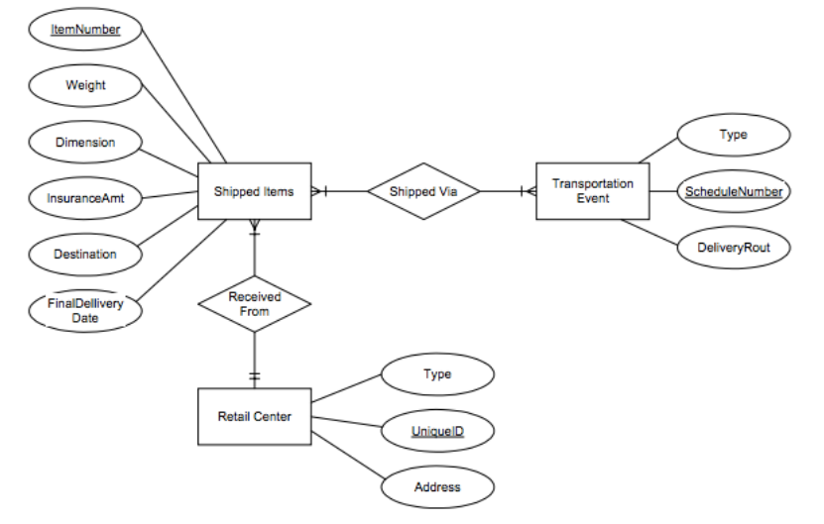
ER DIAGRAM (TEXT REPRESENTATION)
Retail_Center
--------------
Center_ID (PK)
Center_Type
Address
Contact_Number
|
| Receives
| 1:M
|
Shipped_Item
--------------
Item_No (PK)
Weight
Dimensions
Insurance_Amount
Destination
Final_Delivery_Date
Current_Status
|
| M:N
| Moved_Through
|
Transportation_Event
---------------------
Schedule_No (PK)
Transport_Type
Delivery_Route
Departure_Time
Arrival_Time

Additional Assumption
A shipment can pass through multiple transportation events before delivery, enabling complete tracking history.

Q2.
Instead of storing all information in a single Exam entity, the design is normalized into Course, Section, Room, and Exam entities to reduce redundancy.
Entities
Course
- Course_ID (PK)
- Course_Name
- Department
- Course_Number
- Credits (extra attribute)
Section (Weak Entity)
- Section_No (Partial Key)
- Enrollment
- Faculty_Name (extra attribute)
Room
- Room_No (PK)
- Capacity
- Building
- Floor (extra attribute)
Exam
- Exam_ID (PK)
- Date
- Time
- Duration

Relationships
Course has Section (1:M)
Section scheduled_in Room (M:1)
Section conducts Exam (1:1)

ER Diagram
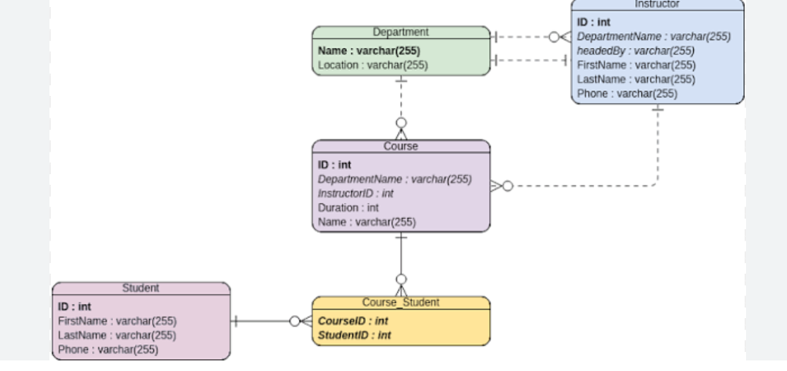
Course
---------
Course_ID (PK)
Course_Name
Department
Course_Number
Credits
|
| 1:M
|
Section (Weak)
---------------
Section_No
Enrollment
Faculty_Name
|
| M:1
|
Room
---------
Room_No (PK)
Capacity
Building
Floor

Section
|
| 1:1
|
Exam
-------
Exam_ID (PK)
Date
Time
Duration

Q3.
The registrar maintains academic records for students, instructors, courses, and enrollments. The Enrollment relationship stores the grade obtained by each student.
Entities
Course
- Course_No (PK)
- Title
- Credits
- Syllabus
Course_Offering
- Offering_ID (PK)
- Year
- Semester
- Section_No
- Timings
- Classroom
Student
- Student_ID (PK)
- Name
- Program
- Email (extra attribute)
Instructor
- Instructor_ID (PK)
- Name
- Department
- Designation

Relationships
Course offers Course_Offering (1:M)
Instructor teaches Course_Offering (1:M)
Student enrolls_in Course_Offering (M:N)
Enrollment Relationship Attributes:
- Grade
- Attendance_Percentage (unique addition)
Course has prerequisite Course (Recursive Relationship)

ER Diagram:
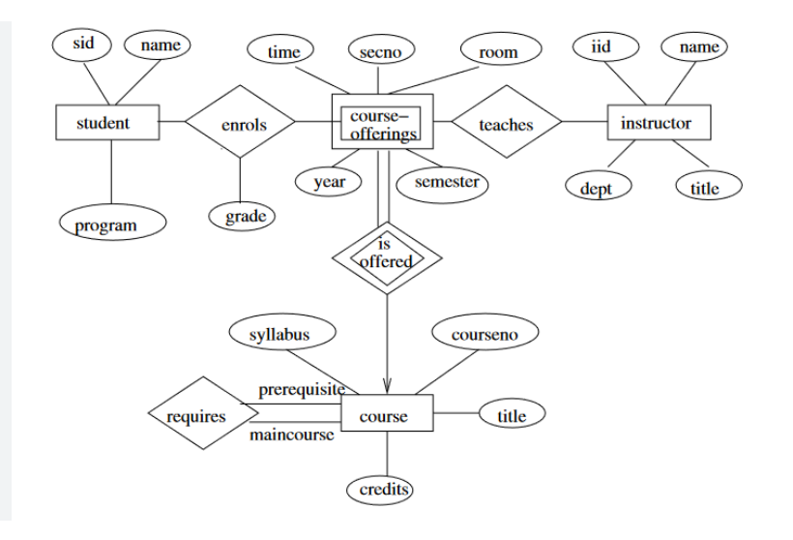
Course
---------
Course_No (PK)
Title
Credits
Syllabus
|
| 1:M
|
Course_Offering
----------------
Offering_ID (PK)
Year
Semester
Section_No
Timings
Classroom
|
| M:1
|
Instructor
------------
Instructor_ID (PK)
Name
Department
Designation

Student
-----------
Student_ID (PK)
Name
Program
Email
|
| M:N
| Enrolls
| (Grade, Attendance)
|
Course_Offering

Course
|
| Recursive Relationship
|
Prerequisite

Q4.
A Hospital Management System maintains records of patients, physicians, medical tests, and treatment history. The proposed ER model separates current treatment from historical records for better data organization.
Entities
Patient
- SSN (PK)
- Name
- Insurance
- Blood_Group (extra attribute)
- Age (extra attribute)
Physician
- Physician_ID (PK)
- Name
- Specialization
- Experience (extra attribute)
Test_Log
- Test_ID (PK)
- Test_Name
- Date
- Time
- Result (extra attribute)
Patient_History
- History_ID (PK)
- Diagnosis
- Treatment
- Follow_Up_Date

Relationships
- Patient undergoes Test_Log (1:M)
- Physician treats Patient (M:N)
- Patient maintains Patient_History (1:M)
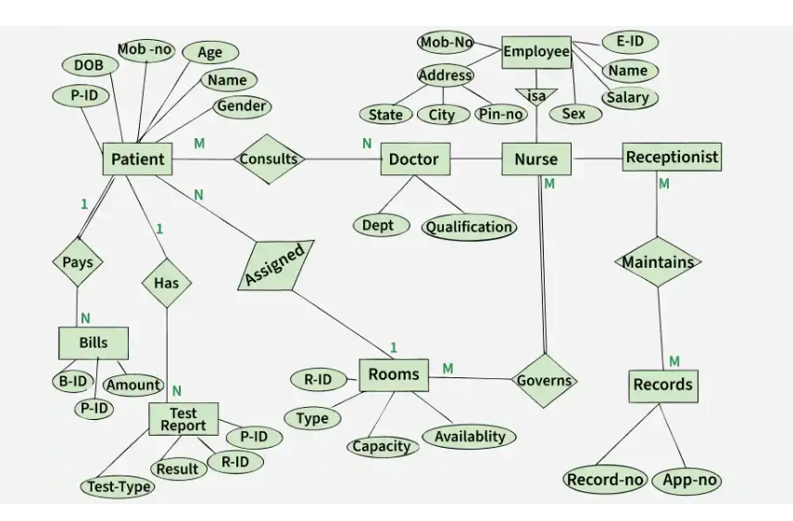

Patient
---------
SSN (PK)
Name
Insurance
Blood_Group
Age
|
| 1:M
|
Test_Log
------------
Test_ID (PK)
Test_Name
Date
Time
Result

Patient
|
| M:N
|
Physician
-------------
Physician_ID (PK)
Name
Specialization
Experience

Patient
|
| 1:M
|
Patient_History
-----------------
History_ID (PK)
Diagnosis
Treatment
Follow_Up_Date

Relational Tables
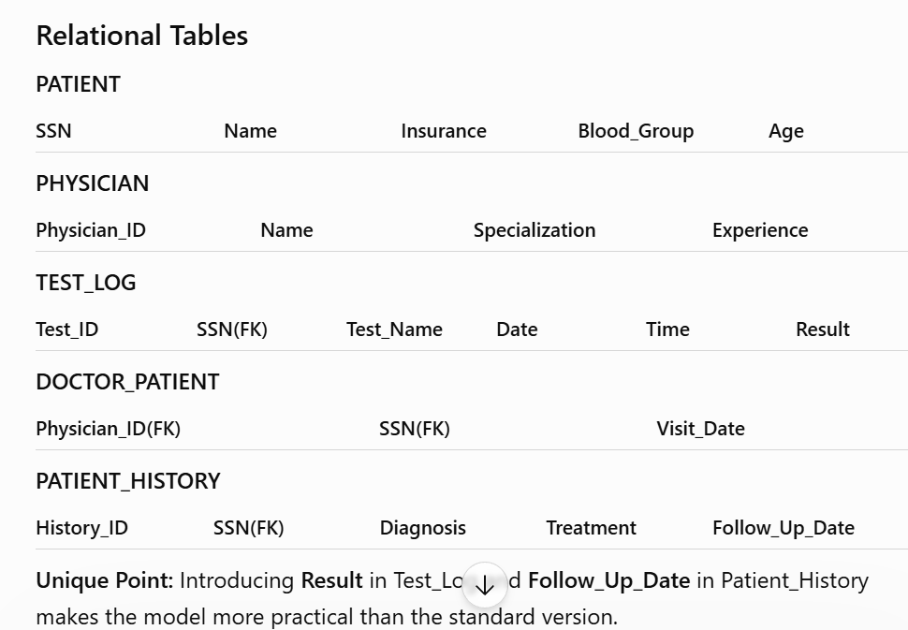

Q5.
This ER model efficiently manages departments, employees, projects, and dependents while tracking project assignments and reporting hierarchy.
Entities
Department
- Dept_ID (PK)
- Dept_Name
- Manager_Start_Date
Employee
- Emp_ID (PK)
- Name
- SSN
- Address
- Salary
- Gender
- DOB
- Email (extra attribute)
Project
- Project_ID (PK)
- Project_Name
- Location
- Budget (extra attribute)
Dependent (Weak Entity)
- Dependent_Name
- Birth_Date
- Relationship
Department_Location (Multivalued Attribute converted into entity)
- Location

Relationships
- Department manages Project (1:M)
- Department employs Employee (1:M)
- Employee works_on Project (M:N)
  - Attribute: Hours_Per_Week
- Employee supervises Employee (Recursive 1:M)
- Employee has Dependent (1:M)
- Department located_at Department_Location (1:M)

ER Diagram
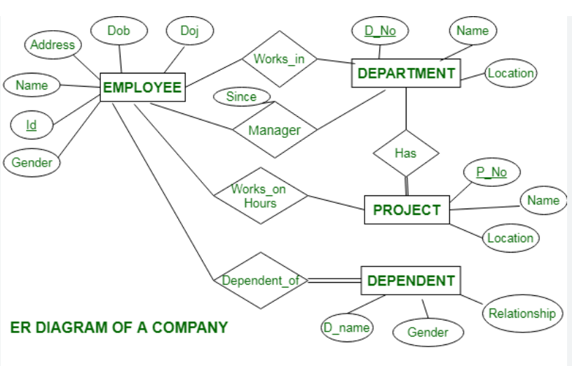
Department
-------------
Dept_ID (PK)
Dept_Name
Manager_Start_Date
|
|1:M
|
Employee
-------------
Emp_ID (PK)
Name
Salary
Gender
DOB
Email
|
|M:N
|
Project
------------
Project_ID (PK)
Project_Name
Location
Budget
(Hours_Per_Week)

Employee
|
|1:M
|
Dependent
-------------
Dependent_Name
Birth_Date
Relationship

Employee
|
|Recursive
|
Supervisor

Q6.
Schema
A schema is the complete blueprint of a database that defines how data is organized, including tables, attributes, relationships, and constraints. It changes very rarely.
Example:
STUDENT
--------
Student_ID
Name
Department
CGPA
This table structure is the schema.
Instance
An instance is the actual data stored in the database at a particular moment. It changes whenever records are inserted, updated, or deleted.
Example
Student_ID | Name | Department | CGPA
101 | Rahul | CSE | 8.9
102 | Ananya | IT | 9.2
This data represents one database instance.

Difference Between Schema and Instance
Schema | Instance
Database design | Actual stored data
Changes rarely | Changes frequently
Created by designers | Modified by users/applications
Describes structure | Represents current contents
Types of Schema
1. Logical Schema
- Defines tables, relationships, constraints, and keys.
- Independent of storage details.
- Used by database designers.
Example: STUDENT, COURSE, ENROLLMENT tables with primary and foreign keys.

2. Physical Schema
- Describes how data is physically stored on disks.
- Includes indexing, partitioning, file organization, and storage allocation.
- Managed by the DBMS.
Example: B+ Tree index on Student_ID for faster searches.

3. View Schema
- Defines what a particular user or application can see.
- Improves security and simplifies data access.
Example:
A faculty member sees:
| Student_ID | Name | CGPA |
The salary or personal details are hidden.

Comparison Table
Feature | Logical Schema | Physical Schema | View Schema
Focus | Database structure | Storage method | User-specific data
Users | Designers | DBAs | End users
Contains | Tables & relationships | Files & indexes | Selected columns/rows
Purpose | Data organization | Performance | Security & simplicity
Conclusion
The schema defines the structure of a database, while an instance represents its current data. The three-schema architecture (Logical, Physical, and View) provides data independence, enhances security, and simplifies database management, making modern DBMSs efficient and scalable.

Q7.

Answer
A Bank Management System stores customer accounts, transactions, loans, and branch information. The ER model below minimizes redundancy and supports secure banking operations.
Entities
1. Customer
- Customer_ID (PK)
- Name
- DOB
- Address
- Phone
- Email (extra attribute)
2. Account
- Account_No (PK)
- Account_Type
- Balance
- Opening_Date
- Status (Active/Inactive)
3. Branch
- Branch_ID (PK)
- Branch_Name
- Address
- IFSC_Code (extra attribute)
4. Loan
- Loan_ID (PK)
- Loan_Type
- Amount
- Interest_Rate
- Loan_Status (extra attribute)
5. Transaction
- Transaction_ID (PK)
- Date
- Time
- Amount
- Transaction_Type

Relationships
- Customer owns Account (1:M)
- Branch maintains Account (1:M)
- Customer applies for Loan (1:M)
- Account records Transaction (1:M)
ER Diagram
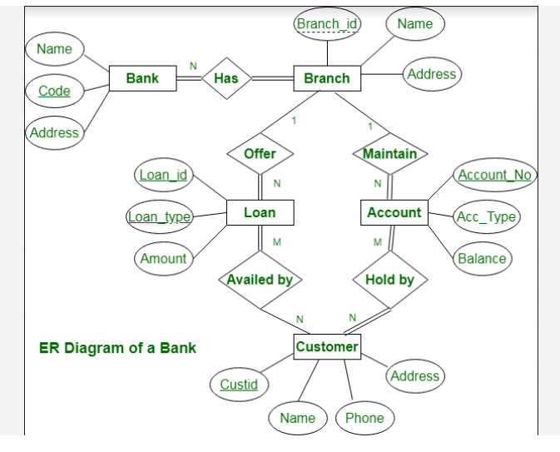
Customer
------------
Customer_ID (PK)
Name
DOB
Address
Phone
Email
|
|1:M
|
Account
-------------
Account_No (PK)
Account_Type
Balance
Opening_Date
Status
|
|1:M
|
Transaction
----------------
Transaction_ID (PK)
Date
Time
Amount
Transaction_Type

Account
|
|M:1
|
Branch
------------
Branch_ID (PK)
Branch_Name
Address
IFSC_Code

Customer
|
|1:M
|
Loan
-----------
Loan_ID (PK)
Loan_Type
Amount
Interest_Rate
Loan_Status

Unique Feature
Unlike basic ER diagrams, this model includes IFSC Code, Account Status, and Loan Status, making it closer to real-world banking software.

Q8.

Answer
The Extended Entity Relationship (EER) Model is an enhancement of the traditional ER model. It introduces advanced concepts such as inheritance, superclass-subclass relationships, and aggregation to model complex real-world systems more accurately.
Advantages of EER
- Reduces redundancy through inheritance.
- Represents complex organizational structures.
- Improves database scalability.
- Makes database design easier to understand and maintain.

1. Generalization
Generalization combines multiple lower-level entities into a common higher-level entity based on shared attributes.
Example
Faculty
Staff
Researcher
↓
Employee
Common attributes inherited:
- Employee_ID
- Name
- Address
- Salary
Purpose: Reduces duplication by storing common attributes only once.

2. Specialization
Specialization divides one general entity into multiple specialized entities based on unique characteristics.
Example
Employee
|
------------------------
| | |
Professor Clerk Technician
Each subclass inherits common attributes while adding its own.
Example:
Professor
- Research_Area
- Publications
Technician
- Skill_Level
- Shift

3. Aggregation
Aggregation treats a relationship as a higher-level entity so it can participate in another relationship.
Example
Employee ---- Works_On ---- Project
|
|
Managed_By
|
Department
Here, the relationship Works_On is aggregated so the Department can manage project assignments rather than individual employees.

Conclusion
The EER model extends the traditional ER model by introducing inheritance and higher-level abstractions. It produces cleaner designs for large databases such as hospitals, universities, ERP systems, and banking applications.

Q9.
Answer
An EER model is suitable for hospitals because doctors, nurses, and administrative staff share common employee information while performing different roles.
Superclass
Employee
- Employee_ID (PK)
- Name
- Address
- Phone
- Salary

Subclasses (Inheritance)
Doctor
- Specialization
- License_No
- Consultation_Fee (extra attribute)
Nurse
- Shift
- Experience
Receptionist
- Counter_No
- Language_Known (extra attribute)

Other Entities
Patient
- Patient_ID (PK)
- Name
- Blood_Group
- Insurance
Medical_Record (Weak Entity)
- Record_No (Partial Key)
- Diagnosis
- Prescription
- Visit_Date
Appointment
- Appointment_ID (PK)
- Date
- Time
- Status

Relationships
- Doctor treats Patient (M:N)
- Patient has Medical_Record (1:M)
- Patient books Appointment (1:M)
- Appointment assigned to Doctor (M:1)

EER Diagram
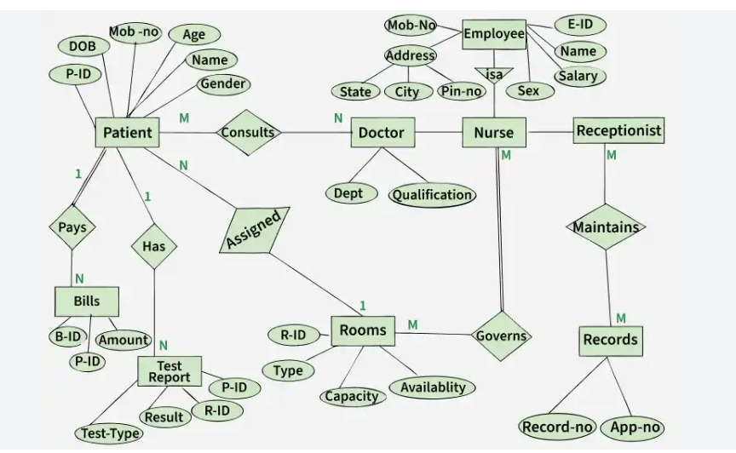

Employee
------------
Employee_ID (PK)
Name
Address
Phone
Salary
|
-------------------------------
| | |
Doctor Nurse Receptionist
Special. Shift Counter_No
License Experience Language

Doctor
|
|Treats
|
Patient
------------
Patient_ID (PK)
Name
Blood_Group
Insurance
|
|1:M
|
Medical_Record (Weak)
-----------------------
Record_No
Diagnosis
Prescription
Visit_Date

Patient
|
|Books
|
Appointment
--------------
Appointment_ID
Date
Time
Status
Unique Feature
Including Receptionist as a subclass and Medical_Record as a weak entity demonstrates a more advanced EER design than the standard textbook solution.

Q10.

A Database Administrator (DBA) is responsible for the installation, maintenance, security, performance, and availability of databases. The DBA ensures that organizational data remains accurate, secure, and accessible.
Responsibilities of a DBA
1. Database Installation and Configuration
- Installs DBMS software.
- Configures database servers.
- Creates initial database structures.
2. Security Management
- Creates user accounts.
- Assigns roles and privileges.
- Prevents unauthorized access using authentication and encryption.
3. Backup and Recovery
- Schedules regular backups.
- Restores data after hardware or software failures.
- Maintains disaster recovery plans.
4. Performance Tuning
- Creates indexes.
- Optimizes SQL queries.
- Monitors memory and storage usage.
- Reduces response time for large databases.
5. Data Integrity
- Enforces primary keys, foreign keys, and constraints.
- Eliminates duplicate or inconsistent data.
6. Database Monitoring
- Tracks server health.
- Monitors storage utilization.
- Detects abnormal activities.
7. Capacity Planning
- Predicts future storage requirements.
- Plans database expansion as organizational data grows.
8. Documentation and Compliance
- Maintains database documentation.
- Ensures compliance with organizational and legal data policies.

Real-Life Example
In an online banking system, the DBA:
- Maintains customer account databases.
- Ensures secure transactions.
- Performs daily backups.
- Optimizes transaction processing.
- Restores services quickly after system failures.

Conclusion
A DBA plays a vital role in ensuring the security, reliability, performance, and availability of a database system. Beyond routine maintenance, a modern DBA also supports scalability, disaster recovery, and regulatory compliance, making them essential to any data-driven organization.

